P250/1
GEOGRAPHY
(PHYSICAL GEOGRAPHY)
PAPER 1
3 hours
PAHISCO EXAMINATIONS BOARD
UGANDA ADVANCED CERTIFICATE OF EDUCATION
MOCK EXAMINATION 2022
GEOGRAPHY PAPER 1
3 HOURS

INSTRUCTIONS TO CANDIDATES
Answer four questions.
Section A is compulsory
At least one question should be answered from section B and one question from section C.
Credit will be given for use of relevant sketch maps, diagrams and specific examples studied in the field.

SECTION A COMPLUSORY:
- Study the 1:50,000 east Africa (UGANDA) KATUNGURU map extract part of sheet 76/1, series Y732, Edition 4-USD and answer the questions that follow.

- State the:
- Man-made feature found at grid reference 801812 (01mk)
- Bearing of the lake kyamwiga (grid reference 820800) from Hipo pools (grid reference 710890) (02mks)

- Draw a cross section along Northing 76 from Easting 74 to Easting 82 and on it mark and name.
- Any three land forms features
- Any two drainage features
- All weather roads (09mks)

- Describe the:
- Relief of the area shown on a map (06mks)
- Relationship between relief and drainage. (04mks)

- Explain the values of the craters to the national economy. (03mks)

- Study the photograph provided below and answer the questions that follow.
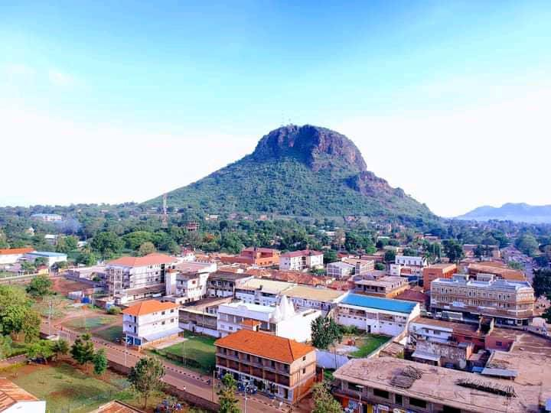

- Draw a landscape sketch of the area shown in the photograph and on it mark and name:
- Any two physiographic regions
- Settlement
- Vegetation (07mks)
- Describe the formation of the landform in the back ground. (07 marks)
- Explain the relationship between relief and land use as shown in the area above. (04mks)
- Giving evidence from the photograph, explain the problems faced by the people living in the area. (05mks)
- Giving reasons for your answer, suggest an area in Easy Africa where the photograph could have been taken. (02mks)

SECTION B
- Account for the formation of the East African rift valley. (25mks)
- Examine the influence of intrusive vulcanicity on the development of relief landforms in east Africa. (25mks)
- Account for the dominance of physical weathering in the semi-arid areas of east Africa. (25mks)

SECTION C
6. (a) Describe how temperature is measured and recorded at a weather station. (10 marks)
(b)To what extent has the position of the overhead sun influenced temperature variations in East Africa. (15 marks)
- To what extent has the natural vegetation of east Africa been modified by human activities?
(25mks)
- a). What is meant by the term “soil profile”? (10mks)
b). Explain the conditions which have influenced the soil profile development in the various parts of East Africa. (15mks)

